New Acetaminophen In UCapIt

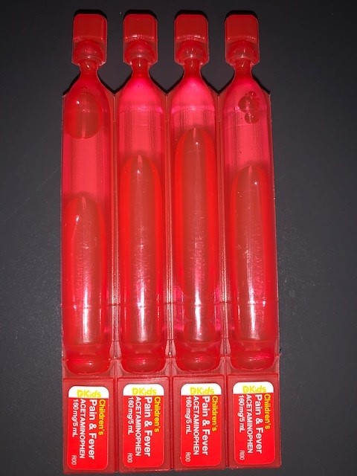
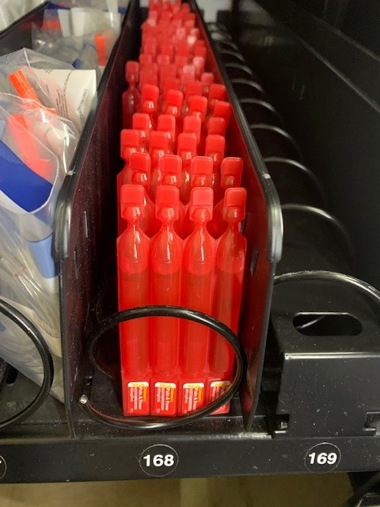
Acetaminophen has (finally) been restocked in the UCapIt, however, due to nationwide shortage we had to utilize a different vendor than the hospital. Because of the difference in vendors the look of the acetaminophen container has changed (as I’m sure many of you have already noticed). The new acetaminophen comes packaged in bright red bullets and should be four bullets in each row. The location of the acetaminophen has changed as well, moving one space to the left, into row 168.

The concentration remains the same (160mg/5ml) which is the same as the cups. This is easy administration for any patient over 2 years of age, however, becomes slightly problematic for the 3 months through 23 months age range. Have no fear though there is a very simple solution utilizing equipment already stocked on the units and that BLS providers should be comfortable with.
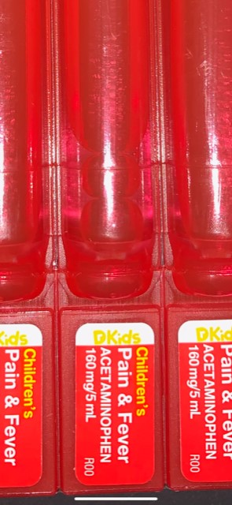
For the dosages above 2 years of age administration is very simple. Pull the desired amount of bullets apart and cut the top off to administer the following dosages based on age (#3, 4, and 5):
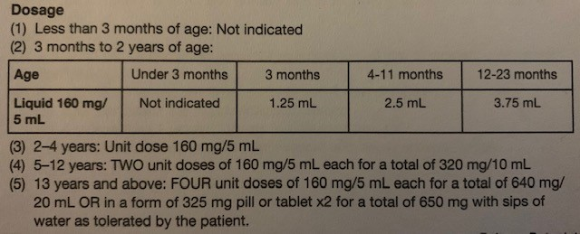

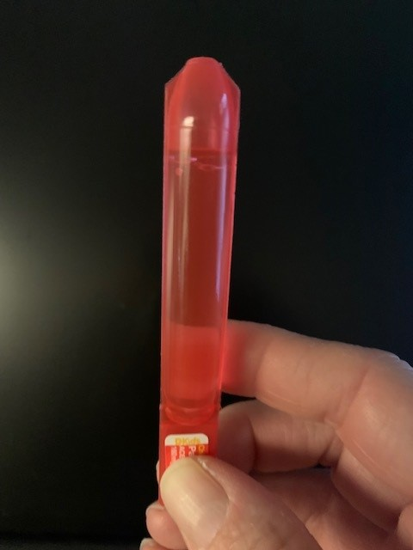
For the little, little ones we must get a little creative. You will only need one bullet for these guys so peel it away from the rest and cut the top off. The trick is to cut very low on the neck to create an opening large enough to accommodate the filter straw (yep, the same ones we use for Epi draw up).
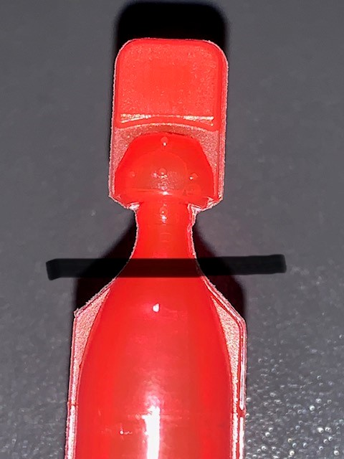
For 3 months through 11 months we will utilize a 3cc syringe and the filter straw and for the 12 through 23 months we will utilize either a 5cc or 10cc syringe dependent upon what your unit carries as we do not stock 5cc syringes through the pyxis at the hospital.
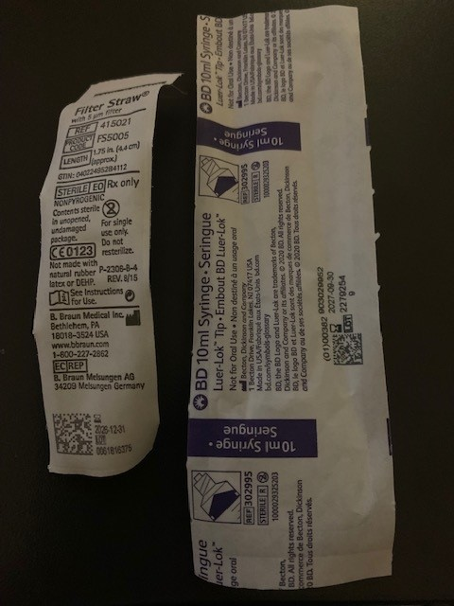
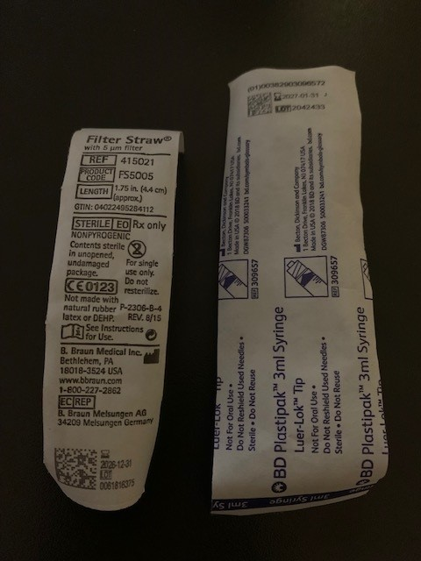
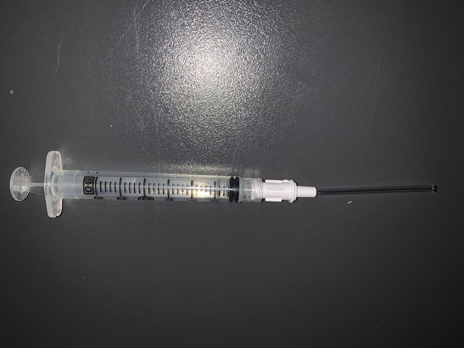

We will be utilizing the filter straws as they allow for slight bending and less chance of piercing through the plastic bullets. Above is a picture of the 3cc syringe with the filter straw attached.

The filter straw will fit into the bullet for easy draw up of the Acetaminophen. *Do NOT invert the bullet as this will allow the medication to freely run out!*
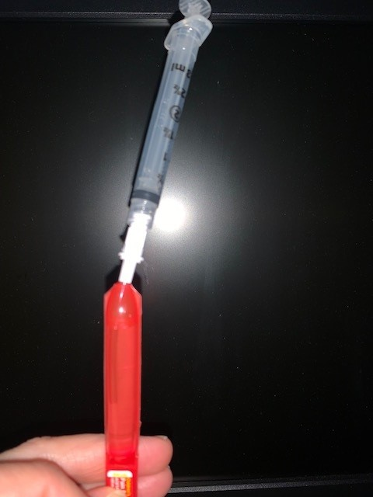

Draw up the desired amount of medication for each age group. See below:
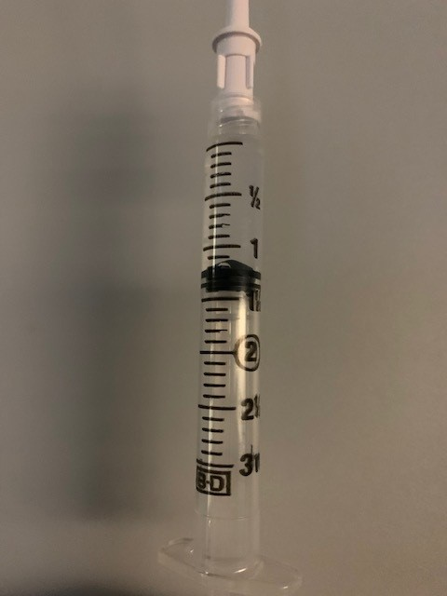
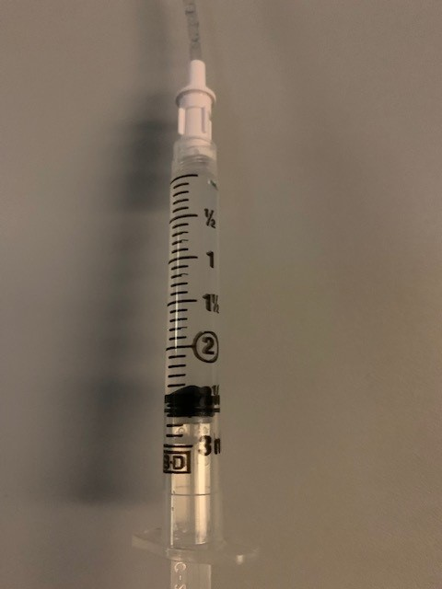
3 months dosage
4-11 months dosage
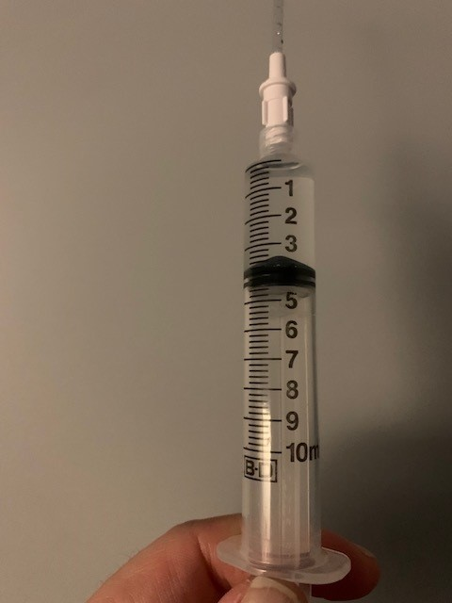
12-23 months dosage

For the larger dosages you may find you have to tilt the bullet and syringe to draw up the amount of medication needed, but again, please do not invert the bullet completely as it will spill out and is VERY sticky stuff.
Please remove the filter straw prior to administration. You can utilize the syringe to give it, and especially for the bigger kids, they make like to administer it themselves through this route.
**We encourage providers, both ALS and BLS, to look at the new medication packaging and make sure you are all comfortable with drawing it up and administering it. Again, the concentration has not changed so really this shouldn’t be too new, except how we need to get it out of the packaging.**

